**Course: Advance Bio Informatics**

**Module Title: Health Security concerns**

**Module No: 147**

**E-Health Types**

* Internet-enabled
* Healthcare applications
* Consumer Health Information
* Personal Health
* Records
* Internet-based Services
* (e-Pharmacy, e-Care incl. email & e-communication, etc.)
* Electronic Health Record (EHR) Systems
* Administrative and Financial Health Systems

**Importance of Healthcare Security**

* Confidentiality/Data Security
* What if something goes wrong?
* System’s Failure
* (Crash or virus causes loss of data)
* Outside force damages (hacker, other), disaster
* Design Issues (Signature, authentication etc.)

**How is Healthcare Security Different from Other Industries?**

* Not bilateral conditions
* Regulated (HIPAA and other regulations)
* Community interest
* Legal issues

**E-Health data exchange**

One of the factors blocking the use of e-Health tools from widespread acceptance is the concern about privacy issues regarding patient records, most specifically the EPR (Electronic patient record). This main concern has to do with the confidentiality of the data. There is also concern about non-confidential data however. Each medical practice has its own jargon and diagnostic tools. To standardize the exchange of information, various coding schemes may be used in combination with international medical standards. Systems that deal with these transfers are often referred to as Health Information Exchange (HIE). Of the forms of e-Health already mentioned, there are roughly two types; front-end data exchange and back-end exchange.

**Front-end exchange**

Typically involves the patient, while back-end exchange does not. A common example of a rather simple front-end exchange is a patient sending a photo taken by mobile phone of a healing wound and sending it by email to the family doctor for control. Such an actions may avoid the cost of an expensive visit to the hospital.

A common example of a back-end exchange is when a patient on vacation visits a doctor who then may request access to the patient's health records, such as medicine prescriptions, x-ray photographs, or blood test results. Such an action may reveal allergies or other prior conditions that are relevant to the visit.

eHealth describes the application of information and communications technologies (ICTs) across the whole range of functions that affect the health sector. “eHealth”, “healthcare IT”, “health ICTs” and “health informatics” are synonymous. eHealth includes tools for health authorities and professionals as well as personalised health systems for patients and citizens. eHealth can therefore be said to cover the interaction between patients and health-service providers, provider-to-provider transmission of data, or peer-to-peer communications between patients and/or health professionals; it can also include health information networks, Electronic Patient Records, Telemedicine services, and personal wearable and portable communicable systems for assisting prevention, diagnosis, treatment, health monitoring and lifestyle management.

eHealth comprises six types of systems:

1. Hospital information system (HIS)

2. Clinical information system (CIS)

3. Other GP or specialty systems

4. Integrated health information exchange networks (HIE/EHR)

5. Telemedicine

6. Secondary-usage non-clinical systems (care analytics, public health and research)

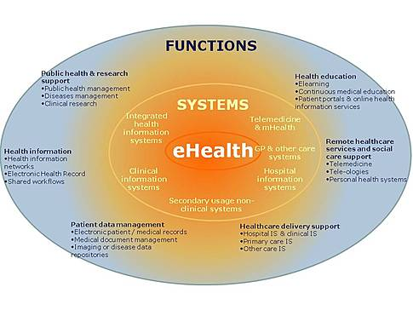

eHealth covers the following six functions:

1. Healthcare delivery support systems

2. Patient Data management

3. Health information exchange

4. Remote healthcare services & social care support

5. Care analytics, public health & research support

6. Health education